Exercise 1: Mocking and Stubbing Scenario: You need to test a service that depends on an external API. Use Mockito to mock the external API and stub its methods. Steps: 1. Create a mock object for the external API. 2. Stub the methods to return predefined values. 3. Write a test case that uses the mock object.

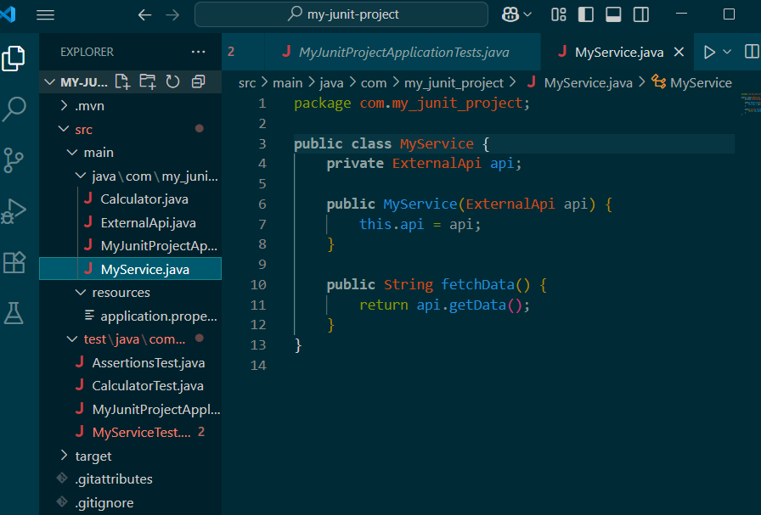

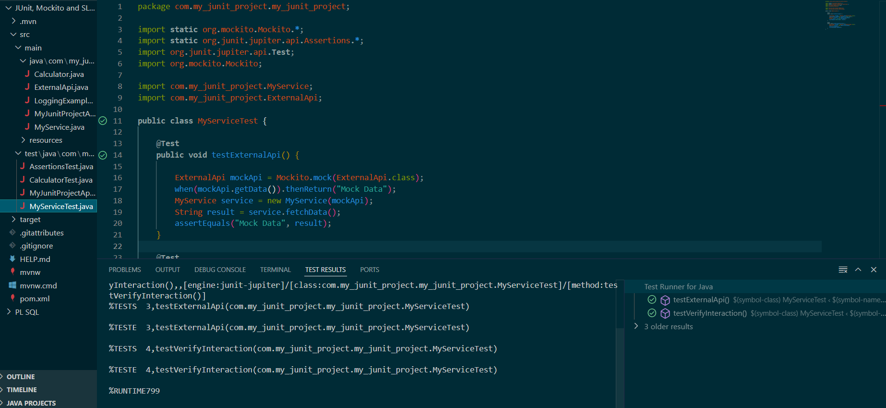

Exercise 2: Verifying Interactions

Scenario:

You need to ensure that a method is called with specific arguments.

Steps:

1. Create a mock object.

2. Call the method with specific arguments.

3. Verify the interaction.

